Advanced Data Analysis and Visualization
in Logistics Operations
An Exploratory and Analytical Study of E-Commerce Delivery Performance
Week 3 Task — Logistics Data Analytics
Dataset: logistics_clean.csv | 112,635 order-item records | Sept 2016 – Sept 2018
Prepared with Python (pandas, matplotlib, seaborn)

Executive Summary
This report analyzes 112,635 order-item records from an e-commerce logistics operation spanning September 2016 to September 2018, covering 98,652 unique orders, 32,948 products, 3,095 sellers, and 72 product categories. The analysis combines exploratory data analysis (EDA) with a series of purpose-built visualizations to surface patterns in delivery performance, shipping cost drivers, and geographic bottlenecks.
Key findings:
- The median delivery time is 10.2 days (mean 12.5 days), and the large majority of orders arrive ahead of the estimated delivery date — only 7.9% of delivered orders arrive later than promised.
- Carrier transit time is the dominant driver of total delivery time (correlation r = 0.92 with delivery_days), far outweighing product price or weight.
- Shipments where the seller and customer are in the same state deliver in 7.9 days on average versus 15.0 days for cross-state shipments, and are roughly 40% less likely to be late (6.0% vs 9.0%).
- Geography is a major bottleneck: customers in Bahia (BA), Espírito Santo (ES), and Goiás (GO) experience the longest average delivery times (15–19 days) and the highest late-delivery rates (up to 13.7%), while São Paulo (SP) — the largest and most seller-dense state — enjoys the fastest, most reliable service (8.7 days, 5.8% late).
- Freight cost scales with product weight (r = 0.61) and, to a lesser degree, with product price (r = 0.41), consistent with weight-based carrier pricing; only 1.9% of shipments are flagged as freight-cost outliers.
- Order volume grew steadily over the observed period, peaking sharply in November 2017 (Black Friday season), which stresses the fulfillment network and is a natural candidate for proactive capacity planning.
These findings point to concrete, prioritized recommendations for reducing delivery time variance and cost, detailed in Section 6.

1. Objective
The objective of this analysis is to deepen practical data-analytics skills by exploring a real-world logistics dataset end-to-end: understanding its structure, conducting rigorous exploratory analysis, building visualizations that reveal operational patterns, and translating those patterns into actionable insights for logistics decision-makers. The exercise emphasizes data-driven decision-making — using quantitative evidence, rather than intuition, to identify where a logistics network is performing well and where it is exposed to delay or cost risk.

2. Dataset Structure
The dataset (logistics_clean.csv) represents order-item-level records from an e-commerce fulfillment operation. Each row corresponds to one item within a customer order, together with product, seller, pricing, and delivery-timing attributes. The table below summarizes the key variables used in this analysis.
Variable | Type | Description
order_id / order_item_id | ID | Unique order and line-item identifiers
order_status / is_delivered | Categorical | Order lifecycle status and delivered flag
product_category_name_english | Categorical | Product category (72 distinct values)
price / freight_value | Numeric (R$) | Item price and shipping cost
order_purchase_timestamp | Datetime | When the order was placed
order_delivered_customer_date | Datetime | When the customer received the order
order_estimated_delivery_date | Date | Delivery date promised at checkout
delivery_days | Numeric | Purchase-to-delivery duration, in days
delivery_delay_days | Numeric | Actual vs. estimated delivery (positive = late)
carrier_transit_days | Numeric | Time in carrier network (hand-off to delivery)
product_weight_g / dimensions | Numeric | Physical shipping attributes
customer_state / seller_state | Categorical | Brazilian state (UF) of each party
freight_outlier | Boolean | Flag for anomalous freight charges

The data covers a two-year window (Sept 2016 – Sept 2018), with 110,181 of 112,635 items (97.8%) successfully delivered; the remainder are in-transit, cancelled, or unavailable at time of extraction and are excluded from delivery-timing analysis.

3. Methodology
The analysis was performed in Python using pandas for data manipulation, and matplotlib/seaborn for visualization. The workflow followed four stages:
- Data loading and cleaning validation — confirming data types, checking for missing values, and filtering delivered orders where delivery-timing analysis required a completed shipment.
- Descriptive statistics — computing measures of central tendency (mean, median), dispersion (standard deviation, IQR), and a Pearson correlation matrix across cost and timing variables.
- Segmented analysis — grouping metrics by product category, customer state, and same-state vs. cross-state shipment lanes to isolate structural bottlenecks.
- Visualization — building ten charts chosen to match the analytical question at hand (distribution, trend, comparison, relationship, and correlation), each interpreted in the context of logistics performance.

3.1 Core analysis code
The snippet below shows the central EDA routine used to compute the summary statistics referenced throughout this report.
import pandas as pd
df = pd.read_csv('logistics_clean.csv')
df['order_purchase_timestamp'] = pd.to_datetime(df['order_purchase_timestamp'])
delivered = df[df['is_delivered'] == 1].copy()
delivered['is_late'] = delivered['delivery_delay_days'] > 0
delivered['same_state'] = delivered['customer_state'] == delivered['seller_state']
# Central tendency & dispersion
print(delivered['delivery_days'].describe())
# Correlation across cost/timing variables
cols = ['price', 'freight_value', 'delivery_days',
'delivery_delay_days', 'carrier_transit_days', 'product_weight_g']
print(delivered[cols].corr().round(2))
# Segmented performance
delivered.groupby('customer_state')['delivery_days'].mean().sort_values(ascending=False)
delivered.groupby('same_state')['is_late'].mean()

4. Exploratory Data Analysis

4.1 Central tendency and dispersion
Summary statistics for the core numeric variables (delivered orders unless noted):
Metric | Mean | Median | Std. Dev. | Notes
Delivery days | 12.47 | 10.18 | 9.45 | Right-skewed; long tail of slow deliveries
Delivery delay (days) | -11.33 | -12.05 | 10.16 | Negative = delivered early vs. estimate
Carrier transit days | 9.19 | 7.06 | 8.63 | Time in carrier hand-off/network
Freight value (R$) | 19.99 | 16.26 | 15.81 | All order items
Price (R$) | 120.65 | 74.99 | 183.64 | Highly right-skewed

Only 7.9% of delivered orders arrive after the estimated delivery date, indicating the business builds a conservative buffer into its promised dates — a strategy that protects customer expectations but may also mask true operational variability (median delivery is over a week earlier than the promise date).

4.2 Correlation structure
A Pearson correlation matrix across price, freight, and delivery-timing variables reveals which factors move together:
 | Price | Freight | Delivery Days | Delay Days | Carrier Days | Weight
Price | 1.00 | 0.41 | 0.06 | 0.00 | 0.04 | 0.34
Freight value | 0.41 | 1.00 | 0.21 | -0.04 | 0.20 | 0.61
Delivery days | 0.06 | 0.21 | 1.00 | 0.60 | 0.92 | 0.09
Delay days | 0.00 | -0.04 | 0.60 | 1.00 | 0.57 | 0.01
Carrier transit days | 0.04 | 0.20 | 0.92 | 0.57 | 1.00 | 0.03
Product weight | 0.34 | 0.61 | 0.09 | 0.01 | 0.03 | 1.00

Two relationships stand out. First, carrier transit time is almost perfectly correlated with total delivery time (r = 0.92) — the time an order spends in the carrier's hands, not order processing, is what determines whether a customer waits a long time. Second, freight cost correlates strongly with product weight (r = 0.61) and moderately with price (r = 0.41), confirming that shipping is priced primarily on physical bulk rather than declared value.

5. Visualizations and Interpretation
Ten visualizations were produced, each selected to match a specific analytical question — distribution shape, trend over time, categorical comparison, bivariate relationship, or multivariate correlation. Every chart is followed by a direct interpretation of what it means operationally.

5.1 Distribution of Delivery Times
A histogram with a density overlay is the right tool to see the overall shape of delivery times — whether they cluster tightly or spread into a long tail of slow shipments.
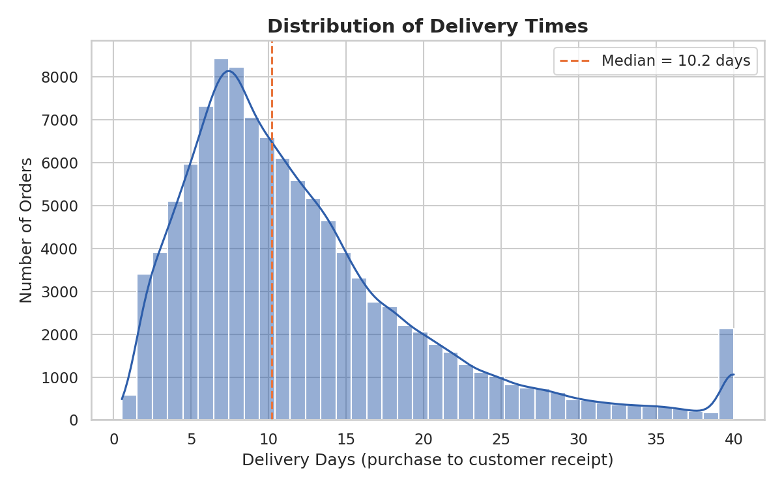
Figure 1. Distribution of delivery days, capped at 40 for readability. Median = 10.2 days.
Insight: The distribution is right-skewed: most orders arrive within 6–16 days, but a meaningful tail extends past 30 days. This tail — not the typical case — is where operational risk and customer dissatisfaction concentrate, and is a better target for intervention than the median.

5.2 Delivery Delay Distribution (On-Time Performance)
Plotting delay relative to the promised date (rather than raw delivery time) directly measures whether the business is meeting its commitments.
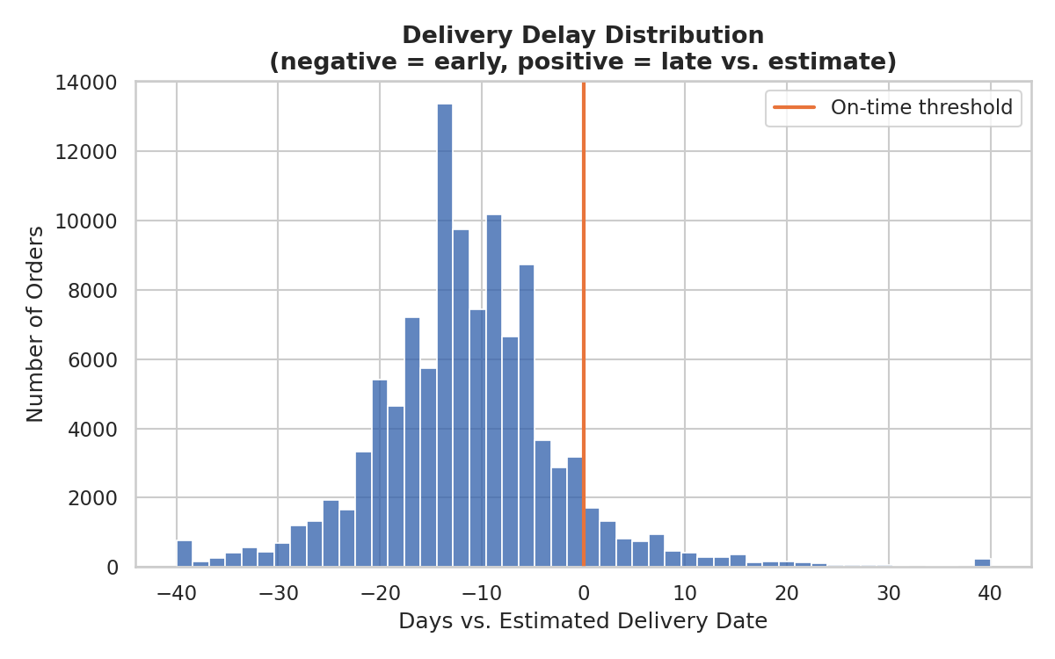
Figure 2. Delivery delay vs. estimate; negative values indicate early delivery.
Insight: The bulk of the distribution sits well to the left of zero, confirming that estimated delivery dates carry substantial built-in slack. The right tail past zero — the 7.9% of late orders — represents the segment most likely to drive support tickets and churn, and is small enough to be addressable with targeted intervention rather than a network-wide overhaul.

5.3 Monthly Shipment Volume Trend
A line chart over time is the standard choice for revealing trend, seasonality, and demand spikes in operational volume.
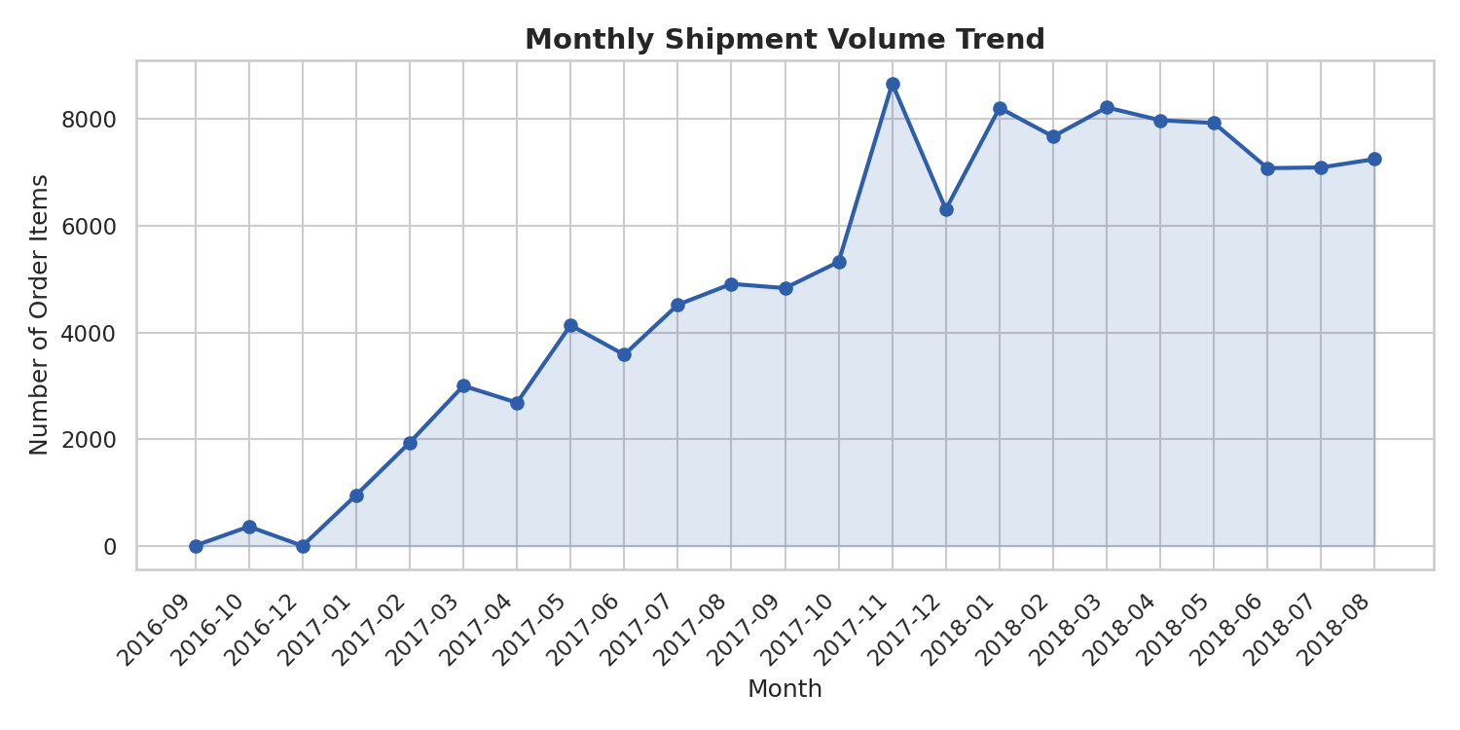
Figure 3. Monthly order-item volume, Jul 2017 – Aug 2018.
Insight: Volume grew steadily through 2017, with a sharp spike in November 2017 (Black Friday / Black November, a major Brazilian retail event) before settling into a higher plateau of 7,000–8,200 items/month through mid-2018. Seasonal peaks like this are exactly when carrier capacity constraints translate into the longest delivery tails seen in Figure 1.

5.4 Average Delivery Time by Product Category
A horizontal bar chart ranks categories clearly and scales well to category-name length, making it ideal for comparing many groups at once.
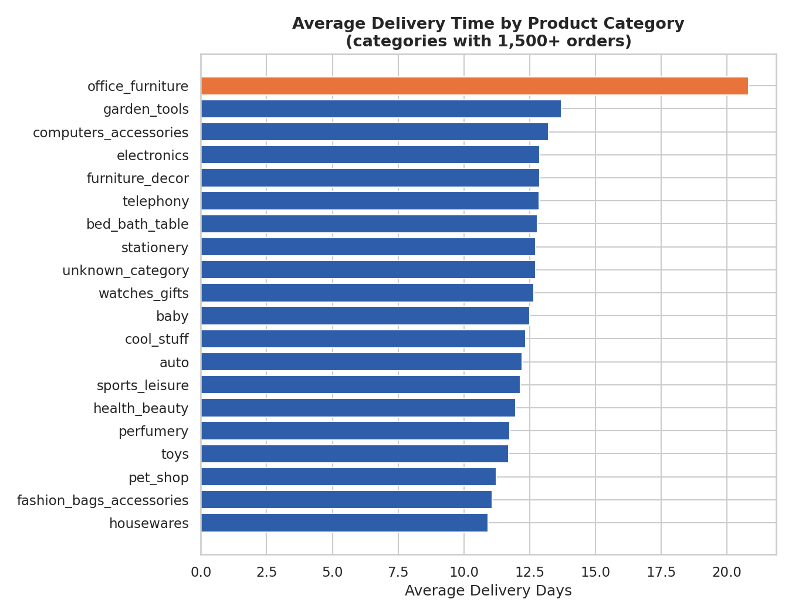
Figure 4. Average delivery days for categories with 1,500+ orders; slowest category highlighted.
Insight: Office furniture stands out as the clear outlier at 20.8 days — nearly double the fastest categories — consistent with bulky, harder-to-ship goods. Garden tools, consoles/games, and computer accessories also run above the network average, suggesting either bulkier packaging, supplier concentration in distant states, or lower carrier prioritization for these categories.

5.5 Freight Cost vs. Product Weight
A scatter plot is the natural choice for examining the relationship between two continuous variables at the individual-shipment level.
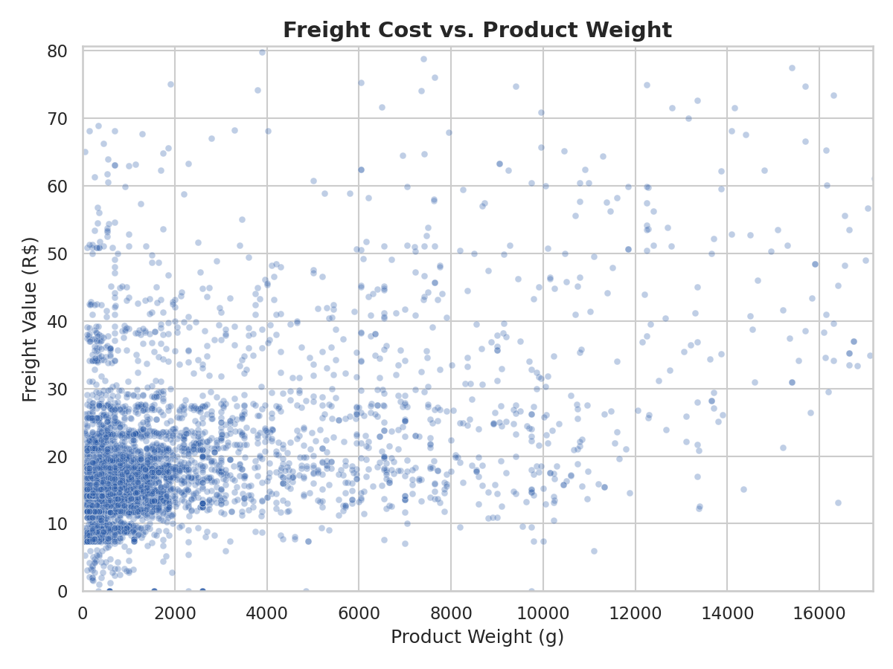
Figure 5. Freight value vs. product weight (6,000-order sample, 99th-percentile capped).
Insight: Freight cost rises with weight but with wide dispersion at every weight level, meaning weight alone does not fully determine shipping cost — carrier zone, dimensional weight, and possibly inconsistent rate application also play a role. This dispersion is a natural place to look for freight-cost outliers and pricing inconsistencies.

5.6 Correlation Matrix: Cost and Delivery Metrics
A heatmap condenses a full correlation matrix into an at-a-glance view, letting readers immediately spot the strongest and weakest relationships without scanning a table of numbers.
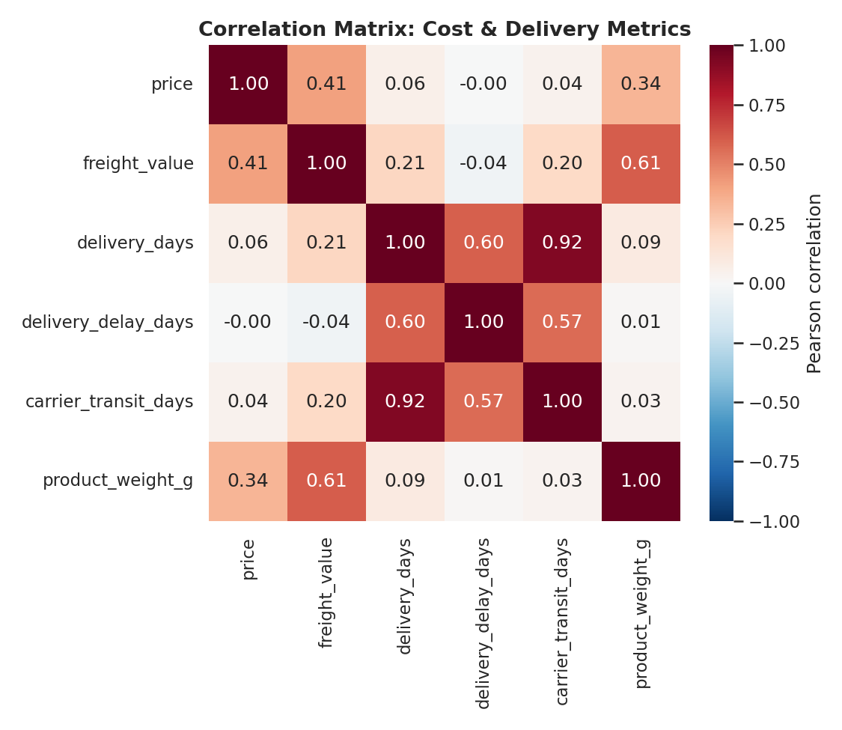
Figure 6. Pearson correlation heatmap across price, freight, and delivery-timing variables.
Insight: The heatmap makes visually obvious what the table in Section 4.2 shows numerically: carrier transit time (0.92) is by far the strongest driver of total delivery time, dwarfing the influence of price or product weight. This should guide where operational investment goes — into carrier and network performance, not into product-level pricing changes.

5.7 Delivery Time Spread by Customer State
A box plot shows both the typical delivery time and its variability per state in one view, which a simple bar chart of averages would hide.
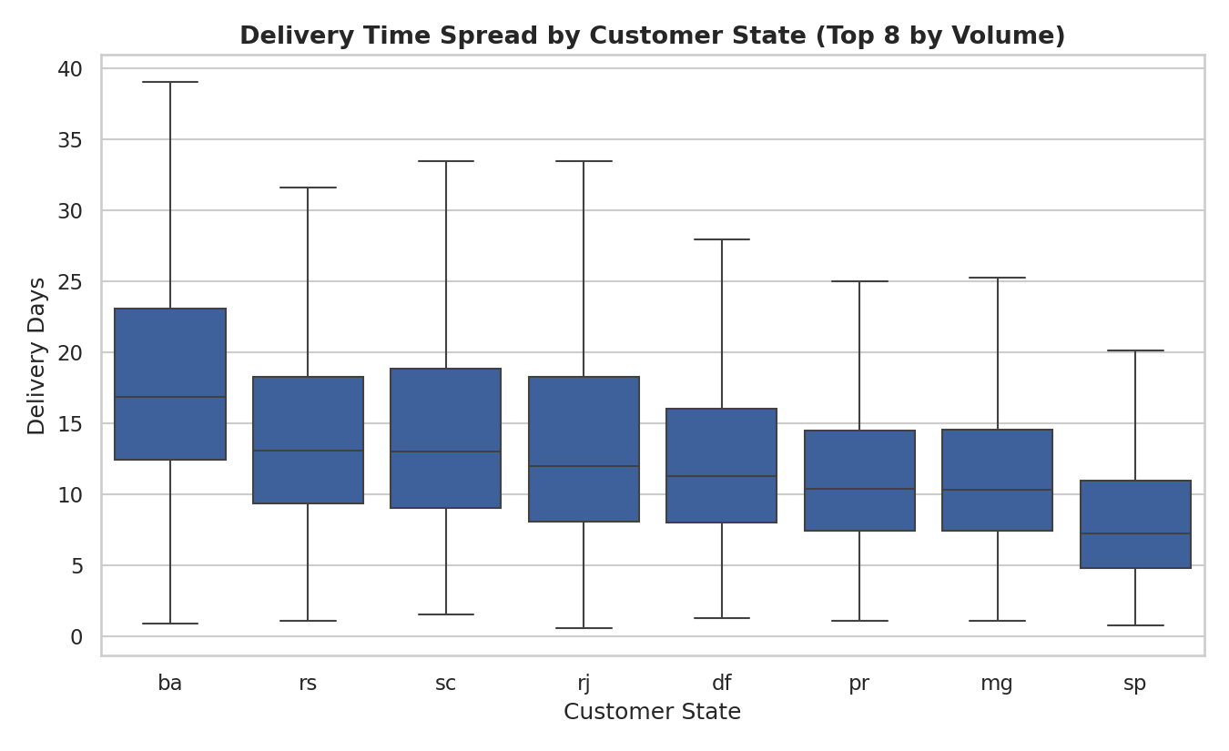
Figure 7. Delivery-day distribution for the 8 highest-volume customer states, ordered by median.
Insight: States such as Bahia (BA) and Espírito Santo (ES) show both a higher median delivery time and a wider interquartile spread than São Paulo (SP), meaning customers there face a double disadvantage: shipments are slower on average and less predictable. SP's tight, low box reflects its proximity to the seller base.

5.8 Late-Delivery Rate by Customer State
A bar chart with a reference line for the network average is the clearest way to flag which segments over- or under-perform a benchmark.
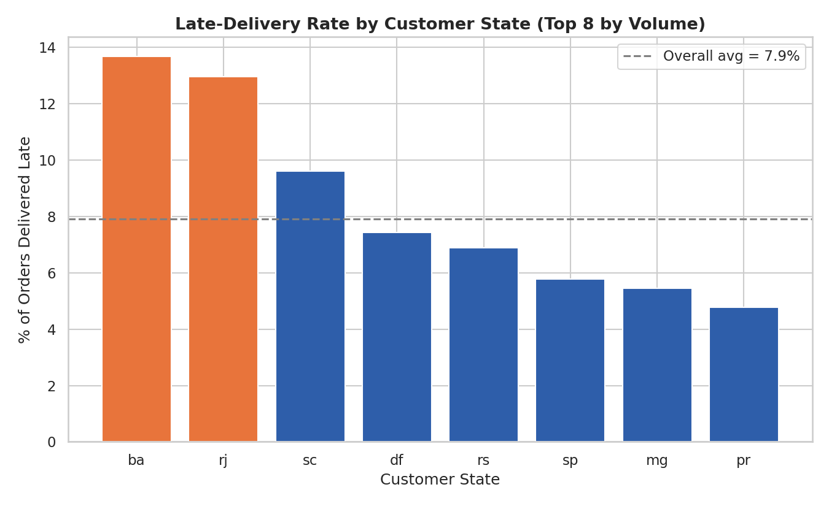
Figure 8. Share of orders delivered after the estimated date, by state, vs. the 7.9% network average.
Insight: Bahia (13.7%), Rio de Janeiro (13.0%), and Espírito Santo (12.2%) all run at roughly 1.5–1.7x the network late-delivery rate, while São Paulo, Minas Gerais, and Paraná sit at or below average. This geographic clustering of late deliveries is consistent with distance-from-hub effects and is a strong candidate for regional carrier renegotiation or regional fulfillment centers.

5.9 Same-State vs. Cross-State Shipments
A paired bar comparison isolates a single structural factor — whether the seller and customer share a state — against two outcome metrics side by side.
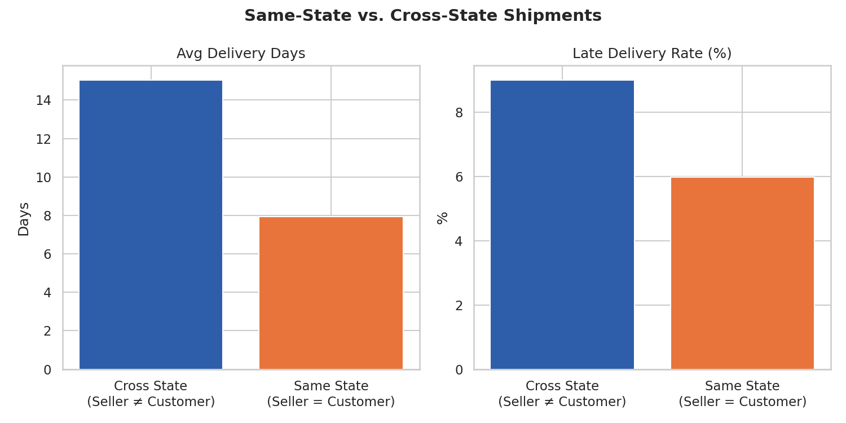
Figure 9. Average delivery days and late-delivery rate, same-state vs. cross-state shipments.
Insight: The effect of shipment distance is stark: same-state shipments average 7.9 days with a 6.0% late rate, while cross-state shipments average 15.0 days — almost double — with a 9.0% late rate. This single factor explains a large share of the state-level variation seen in Figures 7 and 8, and points directly toward the value of regional fulfillment or local seller sourcing.

5.10 Order Price vs. Freight Value
Adding a regression line to a scatter plot quantifies the direction and strength of the price–freight relationship beyond what the correlation coefficient alone conveys visually.
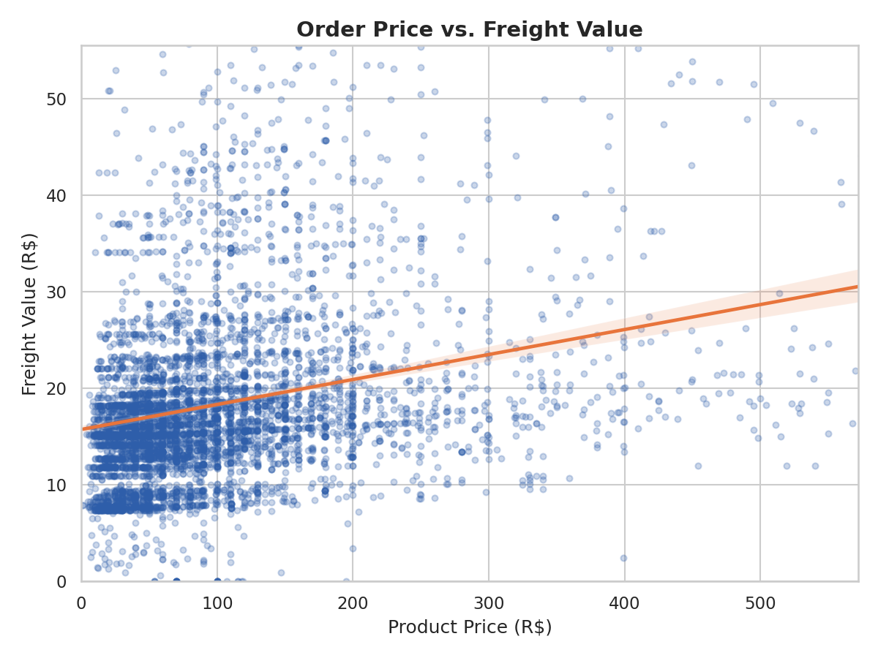
Figure 10. Price vs. freight value with fitted trend line (freight outliers excluded, 98th-percentile capped).
Insight: Freight rises with price but far more gently than one-to-one, and the relationship is noisy — many low-priced items still carry substantial freight charges. This reinforces that freight pricing is driven more by physical shipping characteristics (Figure 5) than by the value of the goods, an important distinction for setting free-shipping thresholds or bundling strategies.

6. Analytical Insights and Recommendations

6.1 Operational efficiency
- Carrier transit time, not order processing, drives total delivery time (r = 0.92). Efficiency initiatives should focus on carrier SLAs, hand-off speed, and network routing rather than warehouse pick/pack time.
- The November demand spike (Figure 3) coincides with the seasons most likely to produce delivery-tail outliers; pre-scaling carrier capacity ahead of known seasonal peaks would directly reduce the long tail seen in Figure 1.

6.2 Cost drivers
- Freight cost is driven primarily by product weight (r = 0.61), with price a secondary factor (r = 0.41). Packaging optimization and dimensional-weight review are more likely to reduce shipping cost than pricing changes.
- Freight-outlier flags are rare (1.9%), suggesting freight pricing is largely consistent — worth spot-checking the outliers directly, but not indicative of a systemic billing problem.

6.3 Bottlenecks
- Geography is the single largest bottleneck identified: cross-state shipments take nearly twice as long (15.0 vs. 7.9 days) and are 50% more likely to be late than same-state shipments.
- Bahia, Espírito Santo, Goiás, and Rio de Janeiro consistently underperform on both delivery speed and reliability — these states are the highest-priority targets for regional distribution investment.
- Office furniture and other bulky categories (Figure 4) face structurally longer delivery times, likely tied to specialized carrier handling and limited seller density for these goods.

6.4 Recommendations
- Prioritize regional fulfillment or micro-warehousing in or near Bahia, Espírito Santo, and Goiás to convert a share of cross-state lanes into faster, cheaper same-state deliveries.
- Renegotiate or diversify carrier contracts specifically for the underperforming states, since transit time — not internal processing — is the primary lever on delivery speed.
- Build seasonal capacity buffers ahead of known peaks (e.g., November) to prevent the demand spike from widening the delivery-time tail.
- Review packaging and dimensional-weight practices for heavy/bulky categories such as office furniture and garden tools to reduce freight cost without sacrificing protection.
- Consider tightening estimated-delivery-date promises where consistent early delivery (median 12 days ahead of estimate) suggests room to set more competitive, still-reliable expectations at checkout.

7. Conclusion
This analysis demonstrates how systematic exploratory analysis and purposeful visualization can convert a raw logistics dataset into concrete operational guidance. The data shows a fundamentally healthy delivery operation — 92% of orders arrive on or ahead of schedule — but with clear, addressable weak points: cross-state shipping lanes, a handful of underserved states, and bulky product categories. Because these bottlenecks are concentrated rather than diffuse, targeted investment (regional fulfillment, carrier renegotiation, seasonal capacity planning) is likely to produce outsized improvements in both delivery speed and cost relative to a broad, unfocused operational overhaul.

Appendix A: Full Visualization Code
The complete Python script used to generate all ten figures in this report (matplotlib/seaborn, using the cleaned dataset).
import pandas as pd, numpy as np
import matplotlib; matplotlib.use('Agg')
import matplotlib.pyplot as plt
import seaborn as sns
sns.set_theme(style='whitegrid', context='notebook')
PALETTE, ACCENT = '#2E5EAA', '#E8743B'
df = pd.read_csv('logistics_clean.csv')
df['order_purchase_timestamp'] = pd.to_datetime(df['order_purchase_timestamp'])
df['purchase_month'] = df['order_purchase_timestamp'].dt.to_period('M').astype(str)
delivered = df[df['is_delivered']==1].copy()
delivered['is_late'] = delivered['delivery_delay_days'] > 0
delivered['same_state'] = delivered['customer_state'] == delivered['seller_state']
# Fig 1: delivery-day distribution
sns.histplot(delivered['delivery_days'].clip(upper=40), bins=40, kde=True, color=PALETTE)
# Fig 3: monthly volume trend
monthly = df.groupby('purchase_month').size()
plt.plot(monthly.index, monthly.values, marker='o', color=PALETTE)
# Fig 4: delivery time by category (top categories only)
top_cats = delivered['product_category_name_english'].value_counts()
top_cats = top_cats[top_cats > 1500].index
g = (delivered[delivered.product_category_name_english.isin(top_cats)]
.groupby('product_category_name_english')['delivery_days'].mean()
.sort_values(ascending=False))
plt.barh(g.index, g.values, color=PALETTE)
# Fig 6: correlation heatmap
cols = ['price','freight_value','delivery_days','delivery_delay_days',
'carrier_transit_days','product_weight_g']
sns.heatmap(delivered[cols].corr(), annot=True, cmap='RdBu_r', center=0)
# Fig 9: same-state vs cross-state comparison
comp = delivered.groupby('same_state').agg(
avg_delivery=('delivery_days','mean'),
late_rate=('is_late', lambda x: x.mean()*100))
# ... (see full report figures for remaining charts; pattern is consistent:
# seaborn/matplotlib plot -> titled, labeled, saved at 150dpi)

